ST. PAUL’S UNIVERSITY, NAIROBI
UNIT: BCS 4103-Advanced Database Systems
GROUP B MEMBERS:
BSCNRB332125
BOBITNRB494624
BSCNRB501824
BOBITNRB616624
BSCNRB154723
TITLE: RETAIL ANALYTICS SYSTEM

Technical Report on the Database Design and Analysis of the Retail Analytics System
1. Introduction
The Retail Analytics System is a database-driven application developed to store, organize and analyze retail transaction data using PostgreSQL. The project demonstrates how relational database technologies can be used to manage retail operations efficiently through data normalization, secure data storage and transaction management.
The application was developed using Node.js, Express.js and PostgreSQL, with RESTful APIs providing communication between the application and the database.
This report presents the database design, explains the system's data flow and architecture, discusses the database security considerations implemented in PostgreSQL, and evaluates how transaction management supports the business requirements of the Retail Analytics System.
2. Database Design
The Retail Analytics System uses PostgreSQL as its database management system. The database was designed using normalized relational tables instead of storing all information in a single table. This reduces data redundancy, improves data integrity and simplifies future maintenance.
The Retail Analytics database contains six main tables, each responsible for storing a specific category of information.
Table | Purpose
retail_raw_data | Stores the imported retail dataset before processing.
customers | Stores customer information.
products | Stores product details.
invoices | Stores invoice information for each customer purchase.
invoiceitems | Stores individual products purchased in each invoice.
productaudit | Stores audit records whenever product information changes.

The tables are linked using primary keys and foreign keys.
The main relationships include:
- A single customer may generate multiple invoices.
- Each invoice may contain multiple invoice items.
- A product may appear in many invoice items.
- Product modifications are automatically recorded in the ProductAudit table through database auditing
This design follows database normalization principles, making the database more efficient while reducing duplicate data.
Figure 1: Entity Relationship Diagram (ERD) for the Retail Analytics Database
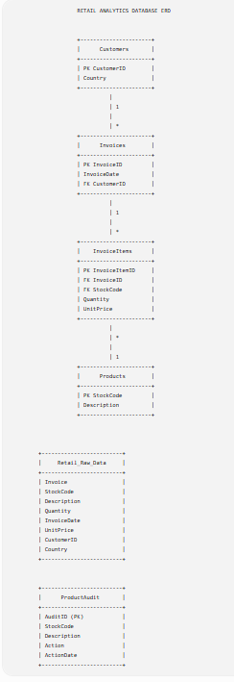

3. Database Architecture and Data Flow
The Retail Analytics System follows a three-layer architecture consisting of the client layer, application layer and database layer.
Client Layer: The client communicates with the system through REST API requests using Postman.
Application Layer: The application layer is built using Node.js and Express.js. It receives requests from users, validates them and communicates with PostgreSQL using the pg package.
Database Layer: The PostgreSQL database stores all system data including customers, products, invoices, invoice items and audit records.
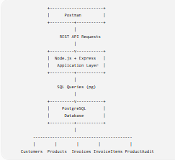
Figure 2: Database Architecture of the Retail Analytics System
Data Flow
The system processes data using the following flow:
- Retail transaction data is imported into the retail_raw_data table.
- The imported data is cleaned and organized.
- The application stores customer information in the Customers table.
- Product information is stored in the Products table.
- Invoice details are stored in the Invoices table.
- Products purchased under each invoice are stored in the InvoiceItems table.
- Whenever product information changes, the ProductAudit table records the change.
- The application retrieves processed data from PostgreSQL and returns it to the client as JSON responses through REST APIs.
This architecture separates application logic from data storage, making the system easier to develop, maintain and scale.
4. Database Security Considerations
Several security measures were considered while implementing the PostgreSQL database.
Authentication: Access to PostgreSQL requires a valid username and password, ensuring that only authorized users can connect to the database.
Environment Variables: Database credentials are stored inside a .env file instead of being hardcoded into the application. This prevents sensitive information from being exposed if the source code is shared.
SQL Injection Prevention: Parameterized SQL queries are used throughout the application. This protects the system against SQL injection attacks by preventing malicious SQL statements from being executed.
Git Version Control and Repository Security
The project source code is managed using Git and hosted on GitHub for version control and collaboration. Sensitive files such as environment variables (.env) and dependency folders (node_modules) are excluded from the repository using a .gitignore file. This prevents confidential information and unnecessary files from being exposed while keeping the repository organized and secure.
Backup and Recovery: Regular PostgreSQL database backups can be created to prevent data loss in case of system failure.
Access Control: Different database users can be assigned different privileges depending on their responsibilities, ensuring users only access data they are authorized to use.
Audit Logging: The ProductAudit table records changes made to product information. This improves accountability by allowing administrators to track modifications made to important records.
5. Transaction Management Requirements
Transaction management is important because the system stores business-critical sales information. A transaction ensures that all related database operations are completed successfully before changes are permanently saved.
For example, when creating a new sale:
- A new invoice is created.
- Invoice items are inserted.
- Product inventory information may be updated where applicable.
- Audit records may be generated.
If one operation fails, the transaction is rolled back so that the database remains consistent.
PostgreSQL supports the ACID properties:
Atomicity: Either all operations succeed or none of them are saved.
Consistency: The database always remains in a valid state after a transaction.
Isolation: Multiple users can perform transactions simultaneously without affecting each other's work.
Durability: Once a transaction has been committed, the data is permanently stored even if the system crashes.
Using transactions helps prevent incomplete sales records, duplicate entries and inconsistent data.
The Retail Analytics System requires that every retail sale is processed accurately and completely. From a business perspective, customers should never receive incomplete invoices, products should not be recorded without an associated sale, and audit records should accurately reflect all product modifications. PostgreSQL transaction management ensures these business requirements are met by guaranteeing that all related operations either complete successfully or are rolled back if an error occurs.
6. Conclusion
The Retail Analytics System demonstrates how PostgreSQL can be used to build a reliable database solution for managing retail sales information. The database was designed using normalized tables to improve efficiency and reduce redundancy.
The use of REST APIs, Express.js and PostgreSQL provides a clean separation between the application and the database. Security measures such as environment variables, parameterized SQL queries and audit logging improve the safety of the system, while PostgreSQL transaction management ensures data consistency and reliability.
Overall, the Retail Analytics System successfully demonstrates the use of PostgreSQL in designing a secure, reliable and normalized database for retail transaction management. The project integrates database concepts such as normalization, security, transaction management and RESTful APIs to satisfy the business requirements of the retail use case.

